**WRITE UP**

**PROJECT: Handling User Authentication**

**Project Description:**

* Set up a standalone project to do unit testing of the user authentication class which is used in the main web application.
* The objective is to create a JUnit class that will test all aspects of the authentication class.

**Application Flow:**

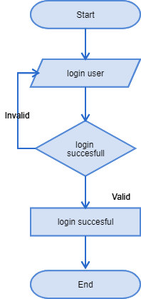

**Core concepts used in project:**

● Eclipse as the IDE  
● Apache Tomcat as the web server  
● Junit 5

**Conclusion:**

This project is designed for Handling User Authentication